Programming Assignment 4 - Documentation
- Problem Statement
Create and implement three classes to create an array of 100 pointers to accounts. Then populate the array using the classes and initialize them, while making the program interactive. Then be able to call any account, with the ability to solve for interest or print the account information. For the testing, write and use each of the writing a class with methods. Then use the main to combine and test all the functions together.

- Requirements
  - Assumptions
- Each class will have attributes and behaviors
- Input set through user input (with ability to interact with account called).
- Output will be handled by the command line

  - Specifications
- The program will contain 3 classes:
  - Account class:
    - Public:
      - Attributes (private):
        - long acctNum
        - double balance
      - Behaviors (public):
        - long getAcct()
        - double getBalance()
        - void setAcct(long acct)
        - void setBalance(double balance)
        - Account(long acct, double bal)
        - string toString()
        - double coputeIntr (int years)
  - Checking class:
    - Attributes:
      - Private:
        - int minIntrBalance
        - int intRate
    - Behaviors:
      - int getMinIntrBalance()
      - void setMinIntrBalance(int lowestBalance)
      - int getRate()
      - void setRate(int rate)
      - double computeIntr(int years)
      - void Checking (long acct, double bal)
      - string toString()
  - Savings class:
    - Attributes (private):
      - double intRate
    - Behaviors (public):
      - double getRate()
      - void setRate(double rate)
      - double computeIntr(int years)
      - void Savings(long acct, double bal, double rate)
      - string toString()

- Decomposition Diagram
- Program:
  - Input
    - Input set through user input (with ability to interact with account called)
  - Process
    - Functions listed under specifications under classes can be called through command line
  - Output
    - Output will be handled by the command line

Class Account
Responsibilities:  +getAcct() : long  +getBalance(): double  +setAcct(acct:long)  +setBalance(balance:double)  +Account(acct:long, bal:double)  +toString():string  +computeIntr(years:int):double virtual  - acctNum : long  - balance: double | Collaborators: NA

Class Checking
Responsibilities:  + getMinIntrBalance(): int  + setMinIntrBalance(lowestBalance:int)  + getRate(): int  + setRate(rate:int)  +computeIntr(years:int):double  +Checking(acct:long, bal:double)  +toString():string  -minIntrBalance: int  -intRate: int | Collaborators: Account

Class Saving
Responsibilities:  +getRate(): double  + setRate(rate:double)  +computeIntr(years:int):double  +Savings(acct:long, bal:double, rate:double)  +toString():string  -intRate: double | Collaborators: Account

- Test Strategy
- Valid Data
- Invalid Data

- Test Plan Version 1
Test Strategy | Test Number | Description | Input | Expected Output | Actual Output | Pass/Fail
Valid Data | 1 | ‘a’ to add account
Valid Data | 2 | ‘r’ to remove account
Valid Data | 3 | ‘g’ to get account
Valid Data | 4 | ‘b’ to set balance
Valid Data | 5 | ‘i’ to set interest
Valid Data | 6 | ‘d’ to display using the toString function
Valid Data | 7 | ‘c’ to wait for user to enter the # of years then display the interest
Valid Data | 8 | ‘q’ to quit processing this account
Invalid Data | 9 | ‘w’ is an invalid input test
- Initial Algorithm
- The program will contain 3 classes:
  - Account class:
    - Public:
      - Attributes (private):
        - long acctNum
        - double balance
      - Behaviors (public):
        - long getAcct()
          - no input parameter
        - double getBalance()
          - no input parameter
        - void setAcct(long acct)
          - input parameter data type value long
        - void setBalance(double balance)
          - input parameter data type value double
        - Account(long acct, double bal)
          - set constructor
        - string toString()
          - no input parameter
        - double coputeIntr (int years)
          - input parameter data type int
  - Checking class:
    - Attributes:
      - Private:
        - int minIntrBalance
        - int intRate
    - Behaviors:
      - Public:
        - int getMinIntrBalance()
          - no input parameter
        - void setMinIntrBalance(int lowestBalance)
          - input parameter data type value int
        - int getRate()
          - input parameter data type value long
        - void setRate(int rate)
          - input parameter data type value int
        - double computeIntr(int years)
          - input parameter data type value int
        - void Checking (long acct, double bal)
          - input parameter data type value long and double
        - string toString()
          - no input parameter
  - Savings class:
    - Attributes:
      - Public:
        - double intRate
    - Behaviors:
      - Public:
        - double getRate()
          - no input parameter
        - void setRate(double rate)
          - input parameter data type value double
        - double computeIntr(int years)
          - input parameter data type value int
        - void Savings(long acct, double bal, double rate)
          - input parameter data type value long, double, and double
        - string toString()
          - no input parameter

- Test Plan Version 2
Test Strategy | Test Number | Description | Input | Expected Output | Actual Output | Pass/Fail
Valid Data | 1 | ‘a’ to add account | a | *add account*
Valid Data | 2 | ‘r’ to remove account | r | *remove account*
Valid Data | 3 | ‘g’ to get account | g | *get account*
Valid Data | 4 | ‘b’ to set balance | b | *set balance*
Valid Data | 5 | ‘i’ to set interest | i | *set interest*
Valid Data | 6 | ‘d’ to display using the toString function | d | *display data*
Valid Data | 7 | ‘c’ to wait for user to enter the # of years then display the interest | c | *wait for user input (# of years)*
Valid Data | 8 | ‘q’ to quit processing this account | q | *quit processing*
Invalid Data | 9 | ‘w’ is an invalid input test | w | *ERROR*

- Code
#include "classes.h"
#include <iostream>
#include <sstream>
#include <string>
using namespace std;

int main()
{
Account *accountPtrs[100];
int acctNum;

for (int i = 0; i < 100; i++)
{
accountPtrs[i] = nullptr;
}

for (int i = 0; i < 5; i++)
{
Checking* c = new Checking(Checking::getNextAccountNumber(), 0);
c->setBalance(1000 + (10 * (c->getAcct())));
accountPtrs[i] = c;
}

for (int i = 5; i < 10; i++)
{
Saving* s = new Saving(Saving::getNextAccountNumber(), 0, .03);
s->setBalance(1000 + (10 * (s->getAcct())));
accountPtrs[i] = s;
}

char action;

//action
while (action != 'q')
{
cout << endl << endl << "How to use:\n 'a': Add Account\n 'r': Remove Account\n 'g': Get Account\n 'b': Set Balance\n 'i': Set Interest\n 'd': Display Account # & Balance\n 'c': Display Interest. Wait to enter in the # of years you wish to calculate for\n 'q': Quit Processing this account\n" << endl;
cin >> action;

switch (action)
{
case 'A': case 'a': //Add Account
char type;

cout << "Enter the account number you wish to add: " << endl;
cin >> acctNum;
cout << "Is this a checking account or a savings account? Enter c or s." << endl;
cin >> type;

if (type == 'c')
{
accountPtrs[acctNum] = new Checking(acctNum, 0.0);
accountPtrs[acctNum]->setBalance((1000 + 10 * acctNum));
cout << "Checking account " << acctNum << " has been added." << endl;
}
else if (type == 's')
{
accountPtrs[acctNum] = new Saving(acctNum, 0.0, 0.03);
accountPtrs[acctNum]->setBalance((100 + 10 * acctNum));
cout << "Saving account " << acctNum << " has been added." << endl;
}
else
{
cout << "Invalid Input. Please try again!" << endl;
}
break;

case 'R': case 'r': //Remove Account
cout << "Enter the account number you wish to remove: " << endl;
cin >> acctNum;
accountPtrs[acctNum] = nullptr;
cout << "Account number " << acctNum << " has been removed." << endl;
break;

case 'G': case 'g': //Get Account
cout << "Enter the account number you wish to view the information of: " << endl;
cin >> acctNum;
cout << accountPtrs[acctNum]->toString();

break;

case 'B': case 'b': //Set Balance
cout << "Enter the account number you wish to change the balance of: " << endl;
cin >> acctNum;
cout << "Is this a checking account or a savings account? Enter c or s." << endl;
cin >> type;

if (type == 'c')
{
double bal;

cout << "What would you like to change the balance to?" << endl;
cin >> bal;
accountPtrs[acctNum]->setBalance(bal);
cout << "Checking account balance is now: $" << bal << endl;
}
else if (type == 's')
{
double bal;

cout << "What would you like to change the balance to?" << endl;
cin >> bal;
accountPtrs[acctNum]->setBalance(bal);
cout << "Saving account balance is now: $" << bal << endl;
}
else
{
cout << "Invalid Input. Please try again!" << endl;
}
break;

case 'I': case 'i': //Set Interest
cout << "Enter the account number you wish to change the interest rate of: " << endl;
cin >> acctNum;
cout << "Is this a savings account? Enter y if it is." << endl;
cin >> type;

if (type == 'y' || type == 'Y')
{
double rate;

cout << "What would you like to change the interest rate to?" << endl;
cin >> rate;
cout << "Checking account interest is now: " << rate << endl;
}
else
{
cout << "It is not a savings account. Please try again!" << endl;
}
break;

case 'D': case 'd': //Display Using the toString function
accountPtrs[acctNum]->toString();
break;

case 'C': case 'c': //Waits for user to enter the # of years then displays the interest
// need to finish
try
{
// something that uses computeIntr()

}
catch (Account::negBal)
{
cout << "Attempt to compute interest using a negative balance";
}
break;

case 'Q': case 'q': //Quit processing this account
cout << "Thank you for processing this account, looking forward to seeing you soon!" << endl;
break;

default:
cout << "Incorrect Input, please try again" << endl;
break;
}
}

system("pause");
return 0;
}

- Updated Algorithm
- The program will contain 3 classes:
  - Account class:
    - Public:
      - Attributes (private):
        - long acctNum
        - double balance
      - Behaviors (public):
        - long getAcct()
          - no input parameter
          - return a long value from function
        - double getBalance()
          - no input parameter
          - return a double value from function
        - void setAcct(long acct)
          - input parameter data type value long
          - return nothing
        - void setBalance(double balance)
          - input parameter data type value double
          - return nothing
        - Account(long acct, double bal)
          - set constructor
          - input parameter data type value long and double
        - string toString()
          - no input parameter
          - return string
        - double coputeIntr (int years)
          - input parameter data type int
          - return double
  - Checking class:
    - Attributes:
      - Private:
        - int minIntrBalance
        - int intRate
    - Behaviors:
      - Public:
        - int getMinIntrBalance()
          - no input parameter
          - return int
        - void setMinIntrBalance(int lowestBalance)
          - input parameter data type value int
          - return nothing
        - int getRate()
          - input parameter data type value long
          - return int
        - void setRate(int rate)
          - input parameter data type value int
          - return nothing
        - double computeIntr(int years)
          - input parameter data type value int
          - return double
        - void Checking (long acct, double bal)
          - input parameter data type value long and double
          - return nothing
        - string toString()
          - no input parameter
          - return string
  - Savings class:
    - Attributes:
      - Public:
        - double intRate
    - Behaviors:
      - Public:
        - double getRate()
          - no input parameter
          - return double
        - void setRate(double rate)
          - input parameter data type value double
          - return nothing
        - double computeIntr(int years)
          - input parameter data type value int
          - return double
        - void Savings(long acct, double bal, double rate)
          - input parameter data type value long, double, and double
          - return nothing
        - string toString()
          - no input parameter
          - return string

- Test Plan Version 3
Test Strategy | Test Number | Description | Input | Expected Output | Actual Output | Pass/Fail
Valid Data | 1 | ‘a’ to add account | A | *add account* | *see screenshot* | Pass
Valid Data | 2 | ‘r’ to remove account | R | *remove account* | *see screenshot* | Pass
Valid Data | 3 | ‘g’ to get account | G | *get account* | *see screenshot* | Fail
Valid Data | 4 | ‘b’ to set balance | B | *set balance* | *see screenshot* | Pass
Valid Data | 5 | ‘i’ to set interest | I | *set interest* | *see screenshot* | Pass
Valid Data | 6 | ‘d’ to display using the toString function | D | *display data* | *see screenshot* | Fail
Valid Data | 7 | ‘c’ to wait for user to enter the # of years then display the interest | C | *wait for user input (# of years)* | *see screenshot* | Fail
Valid Data | 8 | ‘q’ to quit processing this account | Q | *quit processing* | *see screenshot* | Pass
Invalid Data | 9 | ‘w’ is an invalid input test | W | *ERROR* | *see screenshot* | Fail

- Screenshots
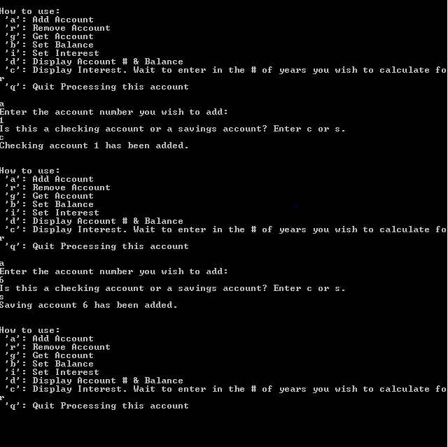
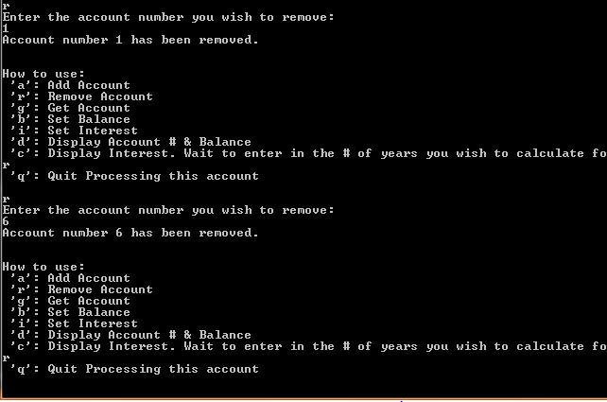
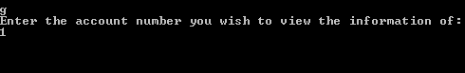
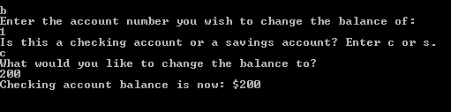
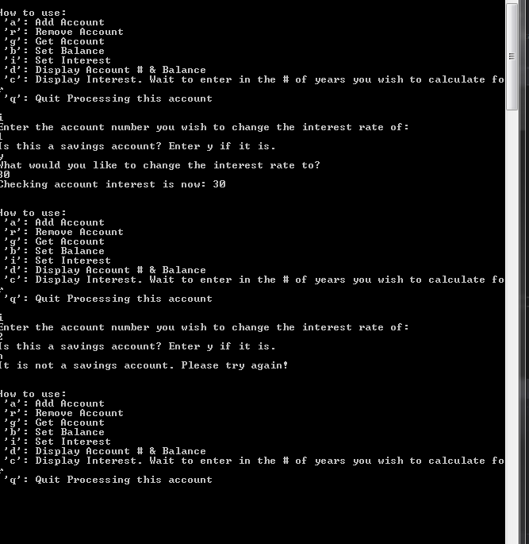
d)
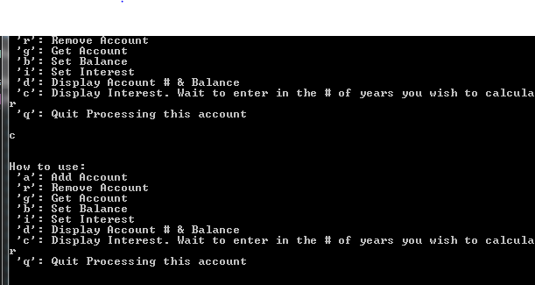
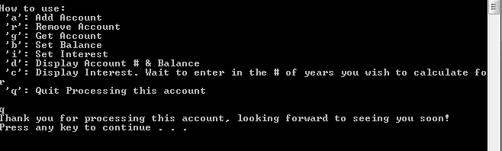
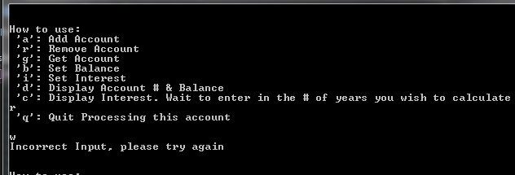

- Error Log
  - Unable to fix the passing of parent to child class functions, therefore unable to get the toString() function to work. Therefore unable to get some of the other actions to work.

- Status
  - The final status of my program was that it needs a lot more time and attention. There is a lot of room for improvement on this assignment.

